**Foundation for Jonesboro Public Schools**

**Nichols Stock Farm Future Educator Scholarship**



Mr. and Mrs. Wayne and Karen Nichols relocated to Jonesboro, Arkansas from Missouri in 1986. Two of their four children graduated from Jonesboro High School. Mr. Nichols earned his BS in agricultural science and MS in agricultural business from University of Central Missouri and was employed with Farm Credit Midsouth. He spent 35 years in the Farm Credit system.

Mrs. Nichols pursued a special education degree from Arkansas State University. She acquired an MS in reading and an Ed.S. in community college from ASU. She spent more than 20 years in education.

Wayne and Karen are still actively involved in both agriculture and education fields in south central Missouri. They share a passion for learning and innovation in their respective career fields. They are committed to assisting the next generation in preparing for the future.

Mr. and Mrs. Nichols chose to provide this scholarship to a Jonesboro High School student because of their appreciation for what the community and educational systems, both secondary and post-secondary, afforded their family.

**Foundation for Jonesboro Public Schools Scholarship Application**

**Nichols Stock Farm Future Educator Scholarship**

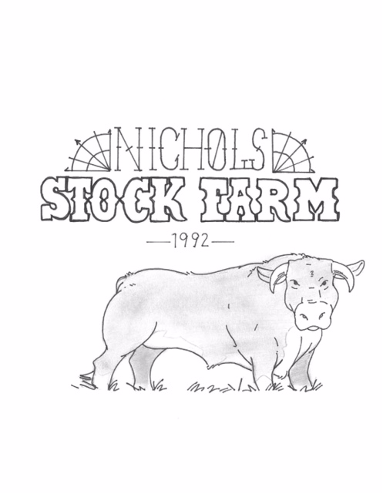

**Scholarship Information:** This scholarship was established by the Nichols family to honor Wayne and Karen Nichols and their commitment to agriculture and education. This fund provides a scholarship for a student who plans to major in the area of education.

**Purpose:** The Wayne and Karen Nichols Family established The Nichols Stock Farm Scholarship to encourage and reward the dedication and commitment necessary to participate in the future advancement of a career in the education field.

**Eligibility:** Graduating high school seniors from Jonesboro High School are eligible to apply for the Nichols Stock Farm Scholarship.

**Criteria:** Applicants must be planning to major in education at a 2-year or 4-year college or university. The recipient must demonstrate financial need, must be an active member in clubs or activities related to education or community service, and must be seeking a career in education or the education field.

**Manner of Selection:** The scholarship recipient shall be selected in a competitive, impartial process based on the criteria outlined in this document. No applicant shall receive special consideration. Selection of this scholarship will be performed by a committee consisting of the following members:

1. Wayne and/or Karen Nichols or a family representative they select

2. One Scholarship Committee member from the Foundation for Jonesboro Public Schools

3. A JHS faculty member selected by the Nichols family and/or the Scholarship Committee

**Amount of Scholarship:** Each year, the Nichols family will disperse $1,000 to the Foundation for Jonesboro Public Schools to fund this scholarship. One recipient will be selected to receive a one-time award of $1,000. These funds are kept in the Foundation for Jonesboro Public Schools bank account under the line item “Nichols Stock Farm Scholarship.” This scholarship will be awarded once each year until funding is no longer dispersed. Checks will be made to the college or university the recipient plans to attend. The following items are required from the recipient upon selection:

1. A copy of your college or university acceptance letter

2. Your Social Security number OR your college ID number

3. Name, title, and address of the contact person at your college or university to whom the

scholarship check should be sent

**Application Deadline:** April 13, 2023

**Return Applications To:** Foundation for Jonesboro Public Schools, Attn. Marcie Cheatham, 2506 Southwest Square, Jonesboro, AR 72401

**Please include the following items:**

**1. Application Form**

The Application Form can be found on page 4 of this packet

**2. High School Transcript**

Please include your current JHS transcript. This is available by request and free of charge at the JHS main office.

**3. Resume**

Your resume should include the following information:

Academic Honors and Special Awards

Honors, Awards, and Activities in the areas of Education and Community Service

Extracurricular Activities

Leadership Positions Held

Career Plans

**4. Personal Statement**

In one or two typewritten pages (double or single spaced, 12 point font), introduce yourself to the scholarship selection committee and explain why you are deserving of this scholarship. **Please include any special circumstances or financial needs you may have.** Also, describe one way in which you have contributed to your community, whether in your family, the classroom, your neighborhood, etc.

**5. One Letter of Recommendation (Optional)**

You may attach one letter for recommendation from any adult **not related to you**. Examples of recommendation letter writers include coaches, teachers, school administrators, pastors, employers, and adult mentors.

**Past Recipients:** 2022– Dominic Mineau, 2021– Bethany Pursifull, 2020 – Michele Gerard,

2019 – Eric Watson, 2018 – Victoria Mayfield

**Nichols Stock Farm Future Educator Scholarship**

**Application Form**

*Please return this form to the Foundation for Jonesboro Public Schools, Attn. Marcie Cheatham, 2506 Southwest Square, Jonesboro, AR 72401 by April 13, 2023. Be sure to include: High School Transcript, Resume, Personal Statement, and optional Letter of Recommendation.*

Student’s Name:

Student’s Address:

Student’s Phone:

Student’s Email:

Parent’s Name:

Parent’s Address:

Parent’s Phone:

Parent’s Email:

GPA:

Current Class Rank:

ACT and/or SAT Score:

College you plan to attend:

Planned major:

Number of years enrolled at Jonesboro Public Schools:

Other scholarships received so far, including amount: